**Planning Proposal Assessment**

**Proposal Summary**

|  |  |  |  |  |
| --- | --- | --- | --- | --- |
| **Applicant** | | Progressive Property Solutions | | |
| **Owner** | | MJM.NL Pty Ltd (previously Terrigal Grosvenor Lodge Pty Ltd) | | |
| **Application Number** | | PP 112/2020 | | |
| **Description of Land subject of planning proposal** | | *Property Description:*  925-993 Central Coast Highway and 137-145 Bakali Road, Forresters Beach  *Legal Description:*  Lots 1-14, 18 & 19 DP 23283, Lots 155 & 156 DP 531710, Lot 51 DP 1028301, Lot 62 DP 838562, Lots 1-8 DP 24187, Lots 1-3 DP 101649, Lot 522 DP 1077907, Lot 1 DP 405510, Lots 1-4 DP 1000694. | | |
| **Site Area** | | 12.261 Ha | | |
| **Existing Use** | | Rural Residential development | | |
| **Proposed Amendments – Gosford Local Environmental Plan 2014 or Central Coast Local Environmental Plan** | | | | |
| ***Provisions*** | ***Existing Provision*** | | ***Proposed Amendment*** | ***Outcome (Supported/Not Supported)*** |
| ***Zoning*** | Lot 522 DP 1077907 -  7(a)/7(c2) under IDO 122  All other lots – 7(c2) under IDO 122 | | Lot 522 DP 1077907 - E2/R2/RE1  Lots 3 DP 101649 – E2/R2  All other lots – R2 | Supported |
| ***Minimum Lot Size*** | 7(a) - 40Ha  7(c2) - 2Ha | | E2 - 40Ha  R2 - 1850m2/550m2.  RE1 – N/A | Supported |
| ***Height of Building*** | 7(a) - 8m  7(c2) – N/A | | E2/R2 - 8.5m  RE1 – N/A | Supported |

**Proposal Report**

**Executive Summary**

This Planning Proposal (PP 112/2020) seeks to rezone a triangular area of land between Bakali Road and the Central Coast Highway, Forresters Beach, from 7(a) Conservation and Scenic Protection (Conservation) and 7(c2) Conservation and Scenic Protection (Scenic Protection - Rural Small Holdings) under Interim Development Order No 122 (IDO 122) to E2 Environmental Conservation, R2 Low Density Residential and RE1 Public Recreation.

This Planning Proposal is similar to one that was originally considered by the former Gosford City Council (fGCC) in 2013 (PP 33/2012) and amended by Central Coast Council in 2019, before being withdrawn by the applicant in November 2020. This withdrawal was in response to a direction from the Department of Planning, Industry and Environment (DPIE) requiring all Planning Proposals over four years old to be determined by 31 December 2020. As Council could not determine the proposal by this date, the applicant withdrew PP 33/2012 and submitted this current proposal.

**The Site**

The subject site (Figure 1) is located between Bakali Road and the Central Coast Highway, Forresters Beach. It is generally triangular in shape with an area of 12.261 Ha. The site comprises 37 parcels of land in total. Of these 32 are standard residential sized lots fronting the Central Coast Highway and five rural-residential sized lots to the west with access from Bakali Road. Four of the five rural residential lots contain dwelling houses with the remaining rural residential lot (Lot 522 DP 1077907) being vacant.

The north-western part of the subject site contains good quality Swamp Sclerophyll Forest on Coastal Floodplains, which is a defined as Endangered Ecological Community (EEC) under the *Biodiversity Conservation Act 2016*.

There is an intermittent overland flowpath from the Central Coast Highway which discharges through this site to the coastal wetland to the west.

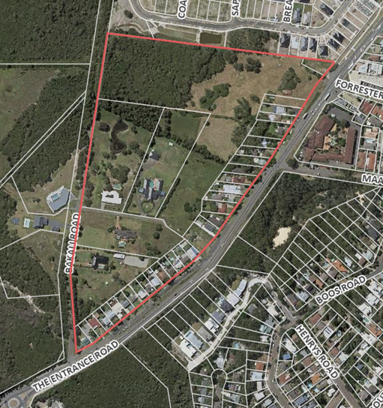

***Figure 1 -*** *Aerial Photograph of Forresters Beach site*

All of the subject 37 lots are zoned 7(c2) Conservation and Scenic Protection (Scenic Protection - Rural Small Holdings) under Interim Development Order No 122 (IDO 122), with the exception of Lot 522 DP 1077907, which is zoned part 7(c2) Conservation and Scenic Protection (Scenic Protection - Rural Small Holdings) and part 7(a) Conservation and Scenic Protection (Conservation) (Figure 2).

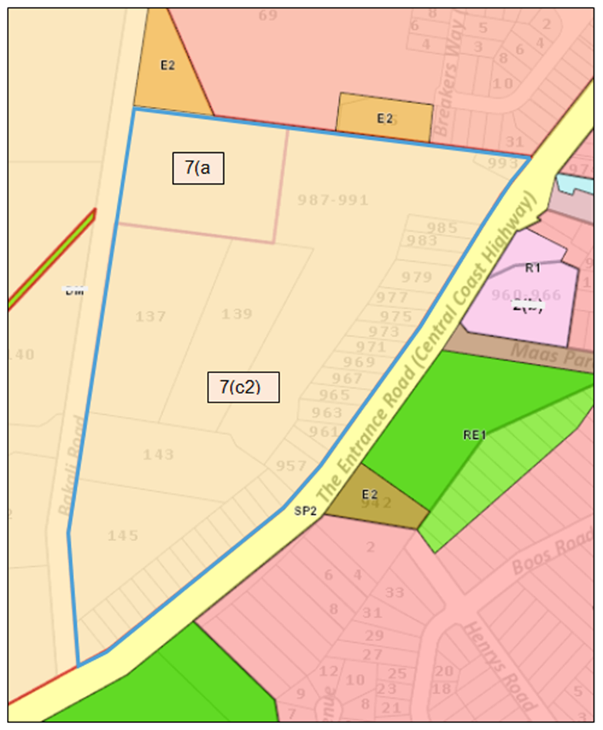

***Figure 2 –*** *Existing Zoning under IDO 122*

**Background**

On 2 July 2013, the former Gosford City Council (fGCC) resolved to prepare a Planning Proposal for the subject site to rezone the land part R2 Low Density Residential and part E2 Environmental Conservation.

On 25 March 2019, Council resolved to amend the Planning Proposal in the following manner:

* Zone 4000m2 of land RE1 Public Recreation.
* Increase the minimum lot size of R2 zoned land fronting Bakali Road to 1850sqm as a transition between the 1 Ha lots to the west and the proposed 550m2 lots within the remainder of the proposed R2 zoned area.
* Enter into a Planning Agreement (PA) with the owner to require:
* Dedication of 4000m2 of land to Council for a park;
* Dedication of land for the purposes of a drainage reserve;
* Undertake roadworks to satisfy the requirements of the NSW Roads and Maritime Service (now Transport for NSW - TfNSW) and Council;
* Implement a Vegetation Management Plan for the area proposed to be zoned E2 Environmental Management;

Since that time Council and the owner had been in negotiations regarding the wording of a draft Planning Agreement relating to land and provisions required for a drainage reserve.

Then, on 1 October 2020, the Department of Planning, Industry and Environment (DPIE) directed Council to determine all Planning Proposals over four years old, which would not be able to be finalised by 31 December 2020.

Even though this Planning Proposal had strategic merit, Council could not finalise it by the 31 December 2020 deadline as the proposal (and related PA) still required community consultation to be undertaken and further consideration by Council.

The applicant was advised by Council staff in mid-October of the DPIE direction meaning that a Council report recommending refusal of the proposal was the only option to meet the deadline. The applicant elected to withdraw the application.

A new Planning Proposal (the current proposal) has been submitted which is essentially the same as the proposal supported by the fGCC in 2013 and amended by Council in March 2019.

**The Proposal**

The Planning Proposal seeks to rezone the subject land from 7(c2) Rural Small Holdings and 7(a) Conservation under IDO 122 to R2 Low Density Residential, RE1 Public Recreation and E2 Environmental Conservation under Gosford Local Environmental Plan 2014 (GLEP 2014) or Central Coast Local Environmental Plan (CCLEP) whichever is in effect at the time (Figure 3).

Specifically, the proposal includes:

1. Rezoning to R2 Low Density Residential, the following land:

- the 32 lots fronting Central Coast Highway;

- Part of Lot 522 DP 1077907 Central Coast Highway;

- Lots 1, 2 and 4 DP 1000694, Bakali Road; and

- Part of Lot 3 DP 1000694, Bakali Road.

2 Rezone part of Lot 522 DP 1077907 and part of Lot 3 DP 1000694 to E2 Environmental Conservation.

3 Rezone part of Lot 522 DP 1077907 to RE1 Public Recreation.

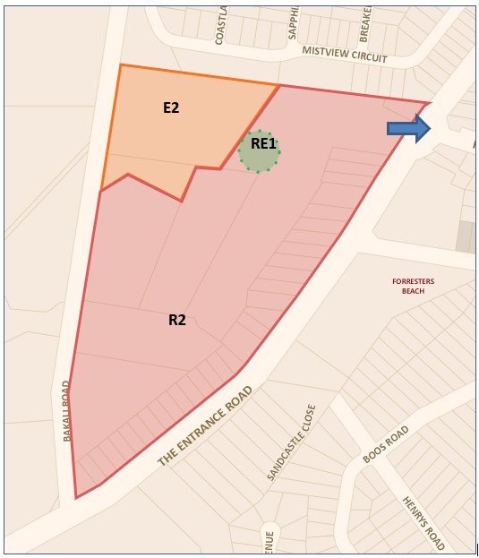

***Figure 3 –****Proposed Zoning of the land with access to Central Coast Highway*

NOTE: The location of the proposed RE1 zone is indicative only as its location is dependent on the upgrade of the Central Coast Highway currently being considered by TfNSW. (If the access location shown in Figure 3 is ruled by TfNSW to be unfeasible then the alternative location for the park would be fronting the Central Coast Highway and access to the site would be via Bakali Road.) The final location and configuration of the park will be resolved following a receipt of the Gateway Determination to proceed with the Planning Proposal and subsequent consultation with TfNSW.

4 Apply the Minimum Lot Size of:

- 1850m2 to land proposed to be zoned R2 Low Density Residential and fronting Bakali Road on Lot 3 DP 1000694 and parts of Lots 1 and 2 DP 1000694;

- 550m2 to all remaining land proposed to be zoned R2 Low Density Residential.

5 Enter into a PA regarding:

- provision of 4,000m2 of land for a local park at no cost to Council;

- rehabilitation and maintenance of 1.8 Ha of E2 zoned land;

- roadworks and intersection works as required.

The land subject to the proposed Planning Agreement is outlined in Figure 4.

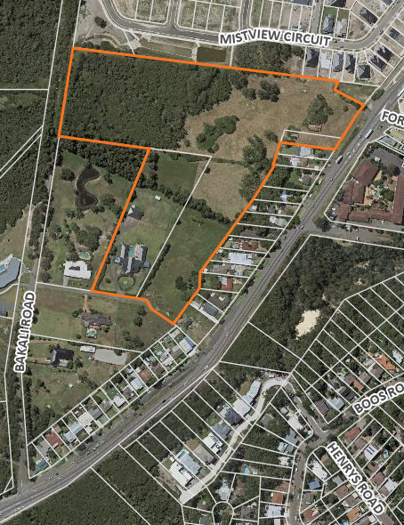

***Figure 4 -*** *Land subject to the proposed Planning Agreement*.

**Assessment**

The rezoning of the subject land to part R2 Low Density Residential and part E2 Environmental Conservation has strategic merit on the basis that:

* The existing lots fronting the Central Coast Highway have a residential character and purpose and do not satisfy the objectives of the current 7(c2) Conservation and Scenic Protection (Rural Small Holdings) zone. They are also serviced with water and sewer. Therefore, it is considered reasonable to formalise the existing development fronting the Central Coast Highway in this Planning Proposal.
* The rezoning of the north-western part of the site from 7(a) Conservation and Scenic Protection (Conservation) and 7(c2) Conservation and Scenic Protection (Rural Small Holdings) to E2 Environmental Conservation is considered to reflect the constraints of the land as this area accommodates an EEC (Swamp Sclerophyll Forest on Coastal Floodplains) and/or is flood liable. The PA will contain measures to ensure that the wetland is protected by way of a Vegetation Management Plan.
* The Planning Proposal has identified land between the Highway frontage lots and Bakali Road as being suitable to be zoned R2 Low Density Residential.

However including a minimum lot size of 550m2 to all the land proposed to be zoned R2 Low Density Residential will result in an abrupt urban edge fronting Bakali Road and facing 7(a) Conservation and Scenic Protection (Conservation) zoned land to the west. In order to ensure a transition between the 7(a) Conservation and Scenic Protection (Conservation) zoned land and the future standard residential development, it is proposed to apply a minimum lot size of 1850m2 to the proposed residential land fronting Bakali Road. This outcome is considered to have strategic planning merit.

* The Planning Agreement will ensure the Planning Proposal will result in a benefit for the public via the dedication of land to Council for a public park and will ensure the cost of managing development impacts, such as roadworks and the conservation of EEC vegetation are met by the proponent.

To ensure that adequate arrangements can and will be made for the management of overland flows, the requirements relating to the determination of the sizing and position of the drainage reserve will be detailed in an accompanying site-specific Development Control Plan (DCP) Chapter. This will enable progression of the rezoning in a timely manner and the issue resolved at subdivision stage when all the issues relating to Central Coast Highway road widening and consequential alterations to the drainage regime are known. Any future subdivision consent will require all land required for drainage reserves to be dedicated to Council.

**Current Status**

The Planning Proposal is essentially the same as that supported by the fGCC in 2013 and amended by Council in March 2019. The only difference may be the location of the proposed park which can only be determined once road widening and intersection options proposed by TfNSW are confirmed.

**Internal Consultation**

Internal consultation for the Planning Proposal has been undertaken as summarised below.

*Environmental Strategies*

The Biodiversity Review Report submitted with the Planning Proposal does not comply with the requirements of the Biodiversity Conservation Act 2016 (BC Act) as the proposal triggers entry into the Biodiversity Offset Scheme (BOS). The following matters are to be addressed, should a Gateway Determination be issued:

• The proposal triggers entry into the BOS via both pathways i.e.; (1) the proposal area impacts on land highlighted on the Biodiversity Values Map; and (2) the total area of native vegetation required for removal exceeds the area clearing threshold. Therefore, a Biodiversity Development Assessment Report (BDAR) prepared in accordance with the Biodiversity Assessment Method (BAM) is required to be submitted to Council to comply with the requirements of the BC Act.

• The Proposal identifies that there will be impacts on areas of the mapped Swift Parrot Important Habitat Area. The BDAR should address the ‘avoid and minimise’ criteria set out in the BAM to address how biodiversity impacts have been avoided.

• A first order stream has been identified in the norther part of the proposal site. Future Development Applications will be required to comply with setback requirement set out in the Water Management Act.

The overall Planning Proposal has strategic planning merit as it will result in the conservation of the endangered ecological community (EEC) listed as Swamp Sclerophyll Forest on Coastal Floodplain by zoning the good quality EEC to E2 Environmental Conservation and zoning the generally cleared land to R2 Low Density Residential and RE1 Public Recreation. Therefore it is considered satisfactory that the above matters be addressed post-Gateway and prior to consultation with public agencies and the community.

*Water and Sewer*

Water and sewer are available to the land. Council is currently undertaking upgrades to the receiving Sewer Pumping Station to optimise its capacity and there will be sufficient residual capacity for the identified development to proceed. Council will recover the cost of these optimisation works as part of Developer Charges at the subdivision stage.

*Flooding and Drainage*

A Flood Study has been submitted and reviewed. Additional technical information is required to be submitted to address some deficiencies, however these matters can be addressed post-Gateway prior to public agency consultation and public exhibition. This will also inform the requirements of a site-specific DCP Chapter relating to this matter.

*Open Space and Recreation*

There is a shortfall of playspaces / parks in Forresters Beach area.

The proposed park is identified in the Playspace Action Plan for a district playspace. There are no other locations where a district playspace can be included for this planning area. A park for this purpose is required to be a single area of 4000m2.

The final location of the park is dependent upon the advice from TfNSW regarding a potential intersection from the site to provide direct access to the Central Coast Highway opposite Forresters Beach Road.

*Traffic*

The Central Coast Highway is subject to a road widening proposal by TfNSW, so the location and type of intersection that could service this site is yet to be determined. Therefore a traffic study will be required to be undertaken post Gateway. It is anticipated that at this time TfNSW will be in a position to advise as to the preferred option regarding vehicular access to the subject site and Council’s traffic engineers will be able to make an informed comment.

The Planning Proposal and supporting traffic study will be referred to TfNSW for formal comment when the Planning Proposal is referred to relevant public agencies.

**External Consultation**

Government agency and public consultation requirements will be detailed in the Gateway Determination and conducted accordingly. It is anticipated that due to the existing development surrounding, and the location, that a number of government agencies may be required to be consulted, such as the following:

• Department of Family and Community and Justice (former NSW Rural Fire Service), regarding bushfire matters;

• Transport for NSW, regarding transportation and road networking matters;

• NSW Biodiversity Conservation Division (BCD) on vegetation and biodiversity matters; and

• Darkinjung Local Aboriginal Land Council and Guringai Tribal Link (also known as Wannangini), regarding Aboriginal heritage values.

**Statutory compliance and strategic justification**

The proposal has been assessed having regard for all State Environmental Planning Policies (SEPPs), Section 9.1 Ministerial Directions and relevant guidelines set out within the Central Coast Regional Plan 2036 as detailed in Attachment 2.

The proposal is considered to be consistent with these considerations, therefore is suitable for forwarding to the Minister of Planning requesting an amended Gateway Determination.

*Social Impacts*

The proposal will expand the available housing choice in terms of providing for additional housing in a locality with good access to services and facilities.

The dedication of the land for a small park will provide open space for the future residents of this subject site and residents in the general locality.

*Environmental Considerations*

The protection of vegetation which qualifies as an EEC will be achieved by zoning the land to E2 Environmental Conservation and ensuring the land is protected via a Vegetation Management Plan by outlining measures for the management of weeds on the site and measures to achieve flora and fauna habitat protection.